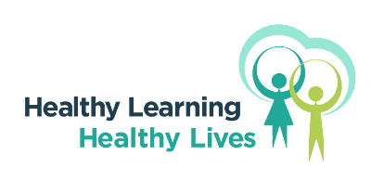**Healthy Learning, Healthy Lives: Relationships, Sex and Health Education (RSHE) Curriculum Sign Up**

The Public Health Healthy Learning, Healthy Lives (HLHL) team along with the Learning Opportunities team at Doncaster Council have purchased a RSHE (5-16) Scheme Of Work, to ensure there is universal access to good quality, evidence-based information and resources that form the teaching of these subjects in Doncaster schools.  It includes learning for all the elements that are required to meet the Department for Education statutory guidance.

To access the curriculum, your setting will need to be signed up to Doncaster’s Healthy Learning, Healthy Lives (HLHL) programme (Doncaster’s Healthy Schools programme). The programme includes an accreditation award and a website with resources, information and useful contacts for teachers, professionals and families of children aged 2 to 18 years. By working towards the award, education settings will be able to not only improve the health and wellbeing of children and their families but will also be meeting a range of local and national priorities.

For Doncaster settings, it is **free** to join Healthy Learning, Healthy Lives, this includes all support, advice and the evaluation to become an accredited healthy school along with access to all the resources the team develop and access to the RSHE curriculum. As the programme is hosted digitally, after the first year there is a small annual charge of £50 **per setting (e.g. per school, or PRU) to cover the admin costs.**

More details about Healthy Learning, Healthy Lives are here; <https://www.healthylearningdoncaster.co.uk/accreditation>

Please fill in the table below to receive access to the curriculum. Many settings will already be signed up to the HLHL programme, but if your school has not yet signed up you will be provided with the information to do so.

|  |  |  |  |  |  |  |  |  |
| --- | --- | --- | --- | --- | --- | --- | --- | --- |
| **School Name** |  | | | | | | | |
| **Setting type** | **Infant school** | **Junior school** | **Primary School** | | **Secondary School** | | **PRU** | **Special School** |
| **RSHE Lead Contact**  **Name** |  | | | **Job role** |  | | | |
| **Telephone** |  | | | **Email** |  | | | |
| **Other contact (e.g. HLHL Lead or SMT)**  **Name** |  | | | **Job role** |  | | | |
| **Telephone** |  | | | **Email** |  | | | |
| **Are you interested in training on this RSHE curriculum?** | **Yes** | | | **No** | | **Don’t know** | | |
| **If yes, for how many people? 2** | | | | | | | |
| **Is your school signed up to Healthy Learning, Healthy Lives (HLHL)?** | **Yes** | | | **No** | | **Don’t know** | | |
| **If yes, are you able to access the evidence and resource ‘wheel’?**  **Yes  No  Don’t know** | | | | | | | |

Please contact [healthylearning@doncaster.gov.uk](mailto:healthylearning@doncaster.gov.uk) with any queries.